+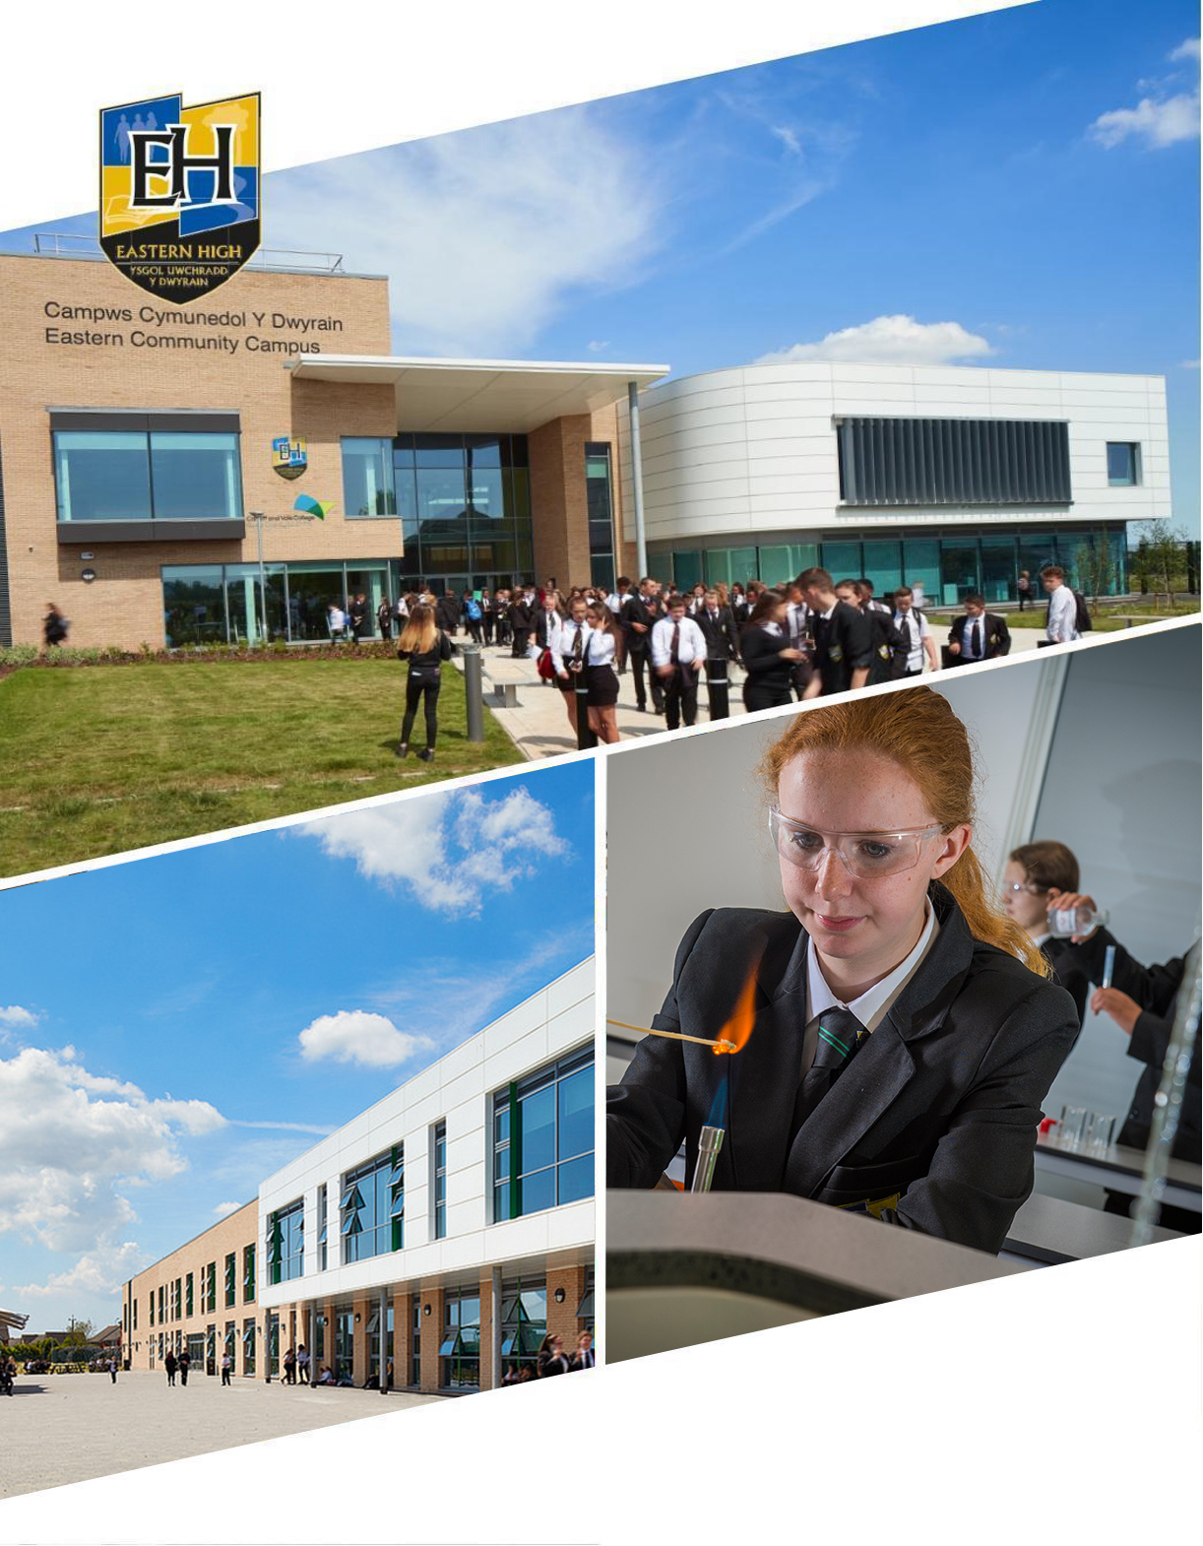
Year 9
Options Booklet 2024

Dear Student,

This is an exciting and very important stage in your education. As you move into Key Stage 4 (Years 10 & 11) you have the opportunity to take control over some aspects of your learning and follow programmes of study, which are of particular interest to you.

As with every other school in Wales, Eastern High will follow a core, compulsory curriculum, which is described in the “Your Questions Answered” section of this booklet. In addition to this you can also make some choices as to the subjects you would prefer to study. It is essential that you take the time to think about these choices, as you will be studying them during Years 10 and 11 and they might affect the qualifications you choose at Post 16 and your career path after that.

There are lots of ways you can gain information to help you choose. Talk to your teachers, pupils in Years 10 & 11 and your relatives; they can all help. The school has appointed a Careers & Aspirations Advisor, Mr Morgan who can provide support, advice and guidance with your option subject choices. There is also a member of staff from Career’s Wales regularly in school; ask them for help too or try the Careers Wales Website.

At the end of the day it is you that has to make the final decision. The most important thing is that you choose the subjects you think you will enjoy most. Don’t forget your tutor is there to help and of course, read this booklet…It is the first step towards your future.

All the best in whatever it is you decide to do.

Best wishes,
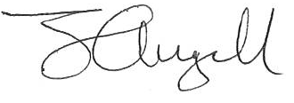

Head Teacher

The Key Stage 4 Curriculum
The Key Stage 4 curriculum is divided into compulsory subjects and optional subjects
Our KS4 Core, Compulsory Subjects
Everyone does the following subjects:
- English Language (Worth 1 GCSE) - This course will start in Year 11
- English Literature (Worth 1 GCSE) - This course will start in Year 9 and be completed in Year 10

- Mathematics (Worth 1 GCSE)
- Mathematics - Numeracy (Worth 1 GCSE)

- Science Double Award (Worth 2 GCSEs)
or
- Science Triple Award (Worth 3 GCSE)
or
- A single science qualification (Worth 1 GCSE)

- Welsh Second Language (Worth 1 GCSE)
or
- Welsh Agored (worth 2x B grades at GCSE)

- Equality and Diversity (Worth 1 or 2 GCSEs)

- Health and Wellbeing and PE (As core subjects these are not studied towards a GCSE but PE can be studied as an Option at GCSE level)

- Welsh Baccalaureate (Worth 1 GCSE grade ‘C’ and above if you gain 4 other C grades) *Some students will also have the opportunity to complete this qualification.

Optional Subjects
Subjects are all GCSEs unless stated otherwise
- Art - Fine Art  - Art - Textiles  - Computer Science  - Digital Technology  - Design and Technology - (Product Design)  - Drama  - Food Science and Nutrition  - French | - Geography  - Health and Social Care  - History  - Media Studies  - Music (BTEC)  - Performing Arts (BTEC)  - Physical Education  - Sociology

YOUR QUESTIONS ANSWERED
Why do I have to make option choices?
Eastern High offers a wide range of options that you can follow. These options are provided to offer the opportunity to maximise your chances of gaining at least 9 qualifications. This will include a literacy qualification, a numeracy qualification, a science qualification and six other qualifications. Within each pathway there are a number of subject choices you can make.
Will my choices affect my career?
Not necessarily. Everyone in the country does a core curriculum which includes all the subjects you need to go on to further education or employment. Usually universities, colleges and employers want to know what your GCSE levels were, rather than what GCSEs you did. English and Mathematics GCSEs are the exceptions to this. You need English and Mathematics Grade C (or B in the case of teaching) and above to progress in many careers and especially if you aim to go on to university.
Apart from your core subjects, you usually do not have to choose a subject at Key Stage 4 in order to study it (or a related subject) at university The exception might be Languages, where unless you are a native speaker of the language, it is advisable to continue studying the language otherwise you may forget what you have already learnt. If you intend studying Art in the future, it may also be advisable to choose the subject so that you can build your portfolio.
Is there any one subject more important than another?
English and Maths are the two subjects that employers and universities consider particularly important. Your choices all have equal importance.
How many subjects can I choose?
You will be able to choose three subjects from four different options blocks that will be shared with you in plenty of time.
In what way are vocational qualifications such as BTEC different to GCSEs?
A BTEC may be equivalent to one or two GCSEs depending on the course followed. The main difference is that the vocational qualifications study an area of work, such as Art and Design, Engineering or Construction. These not only develop your knowledge and understanding of how these areas operate, but give you the opportunity to develop skills which are relevant to this area of work. A GCSE on the other hand, develops your understanding and knowledge of the specific subject.
Does choosing a vocational qualification mean I have to follow a career in this area?
No, not if you do not want to. Remember it counts as equivalent to one or two GCSEs. Employers, universities and colleges want to know the grades you achieve rather than what courses you did.

How can I decide what subjects are best for me?
Ask yourself the following 2 questions:
‘What do I enjoy most?’
‘What am I best at?’

Who can help me decide what to choose?
Listen to advice from your parents or carers, teachers, friends, older brothers and sisters, but at the end of the day make sure you make the final decision.
Don’t pick a subject just because:
- your friend is doing it. You may not be in the same class and they are very likely to have different tastes to you.
- you like a teacher. You may not get the same teacher.
- your parents or carer tells you to. Sorry parents/carers, but it is important that a course is picked because the pupil enjoys the subject. If interested in the subject, your child will be motivated. Motivation is the key to success.

Am I guaranteed to get onto the subjects that I choose?
Unfortunately, if there are not enough pupils choosing a course, we cannot run it. Therefore, you may not get your first choice. Normally this doesn’t happen to many pupils.
We could limit the number of subjects we offer and make sure they all run, but this would then limit your choice.
It may also be the case that two of the subjects you choose have to run on the timetable at the same time and this will mean you will have to choose between them. Again, this doesn’t happen often.


Core Curriculum - English Literature
Qualification: GCSE English Literature (English Language to be completed in Yr 11)
Examination board: WJEC
Duration: 2 years
Best point of contact: kkennedydunn@easternhigh.org.uk

What are the main topics I will study for this qualification?
This GCSE specification in English Literature is based on the conviction that the study of literature should centre on an informed personal response and a critical understanding of a range of texts in the genres of prose, poetry, and drama. This qualification is made up of two externally assessed units, and one internally assessed unit. The two externally assessed units test learners’ knowledge and understanding of prose from different cultures, contemporary unseen poetry and literary heritage and contemporary drama/prose. The internally assessed unit tests learners’ knowledge and understanding of a play by Shakespeare and Welsh writing in English.
How will I be assessed in this subject?
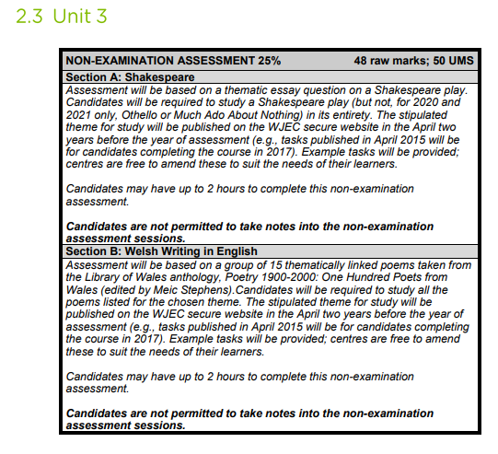
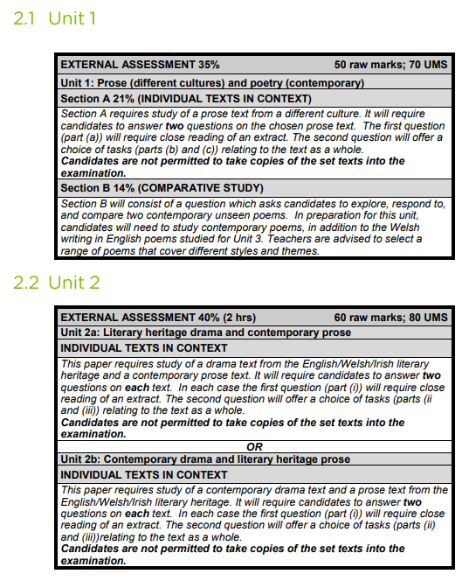
Important information
- Unit 3 Coursework component will be completed by the end of Year 9
- Year 10 focus is on the two exams outlined above. Texts to be studied are:
Unit 1 Exam (January 2025) - Of Mice and Men & Unseen Poetry
Unit 2a Exam (May/June 2025) - An Inspector Calls & Heroes
- Students will either be entered for Higher tier or Foundation Tier
- The English Literature GCSE qualification will be completed in Year 10. The English Language GCSE qualification will be delivered and completed in Year 11
What can I do at home to support my studies?
- Watch the film/TV adaptations of the set texts together;
- Look at the sample exam papers and become familiar with the types of texts and questions;
- Complete revision packs with your child, at home; and
- Set your child timed writing tasks, and give them feedback in terms of content and spelling, punctuation and grammar.
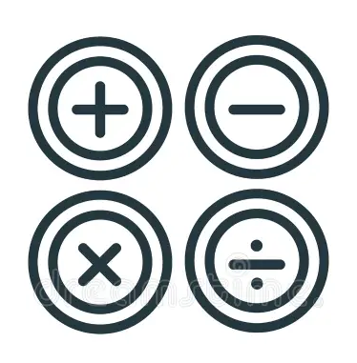
Core Curriculum - Mathematics
Qualification: GCSE Mathematics and Numeracy
Examination board: WJEC
Duration: 2 years
Best point of contact: lrees@easternhigh.org.uk

What are the main topics I will study for this qualification?
GCSE Mathematics will build on and progress from the levels of mathematics expected at the end of KS3 through the National Curriculum Programme of Study for Mathematics. Whilst GCSE in Mathematics – Numeracy will assess the mathematics that learners will need in their everyday lives, in the world of work, and in other general curriculum areas, GCSE Mathematics will extend to aspects of mathematics needed for progression to scientific, technical or further mathematical study.
The following table summarises the way in which the mathematical content will be divided across the two mathematics GCSEs (GCSE Mathematics – Numeracy and GCSE Mathematics).
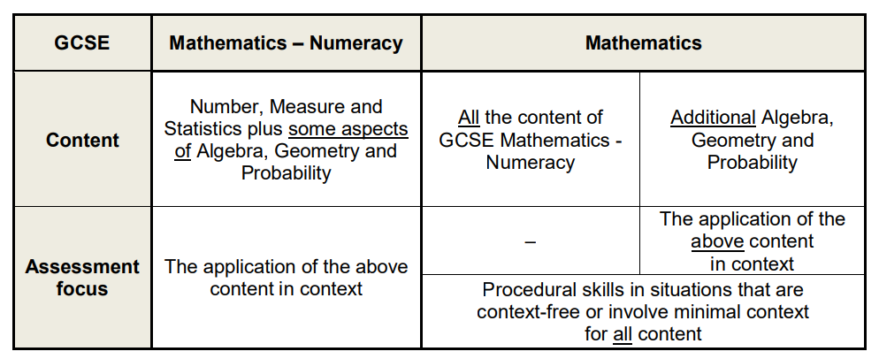
How will I be assessed in this subject?
There are 3 tiers of entry for this qualification.
Higher Tier: Grades A* – C Intermediate Tier: Grades B – E Foundation Tier: Grades D – G
Unit 1: Non-calculator Written examination Higher: 1 hour 45 minutes (80 marks) Intermediate:1 hour 45 minutes (80 marks) Foundation: 1 hour 30 minutes (65 marks) 50% of qualification
Unit 2: Calculator Written examination Higher: 1 hour 45 minutes (80 marks) Intermediate:1 hour 45 minutes (80 marks) Foundation: 1 hour 30 minutes (65 marks) 50% of qualification.
What can I do at home to support my studies?
- Use exercise books to look over class work
- Attend revision sessions
- Use Mathswatch to watch videos to support learning.
- Make sure you know basic maths number skills e.g. addition, subtraction, multiplication and division.

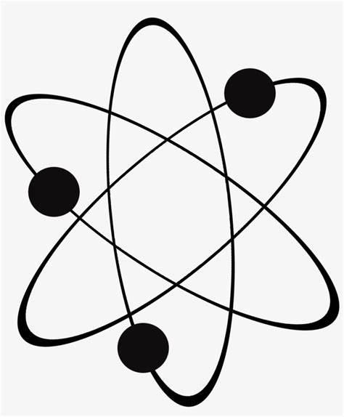
Core Curriculum - Science
Qualification: GCSE Science
Examination board: WJEC
Duration: 2 years
Best point of contact: rbassett@easternhigh.org.uk

What are the main topics I will study for this qualification?
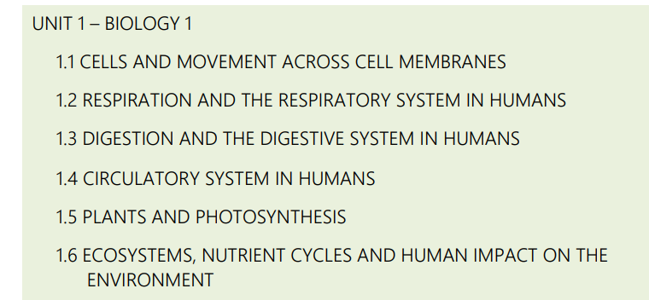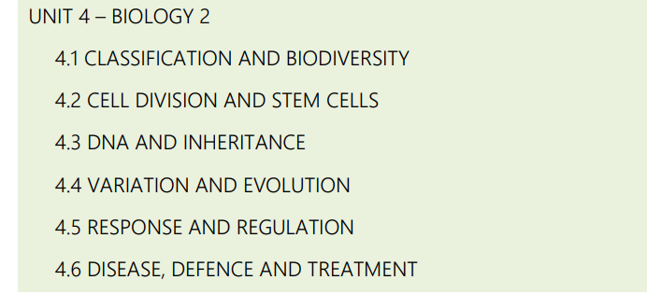
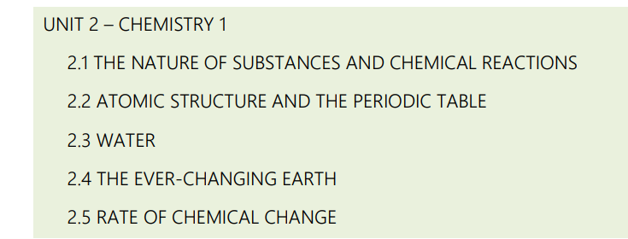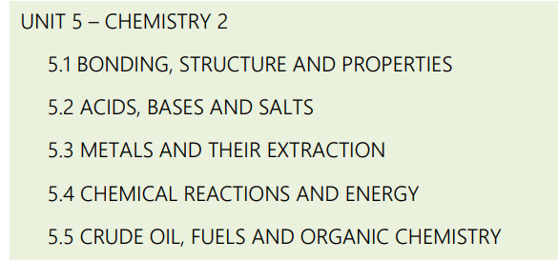
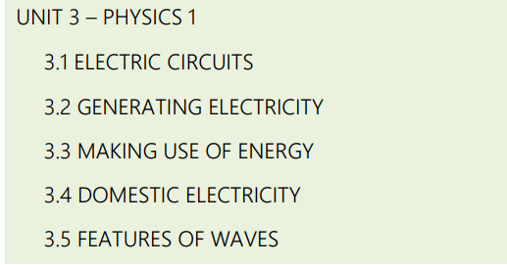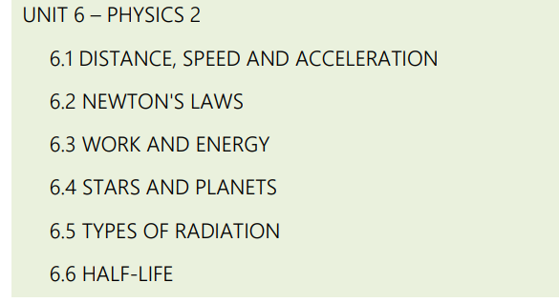
How will I be assessed in this subject?
There are 2 tiers for science.
Higher Tier A*-E; Foundation Tier C-G
Regardless of the tier you will sit 3 exams in year 10 (45% of the overall qualification) and 3 exams in year 11 (45% of the overall qualification) as well as coursework ( non-tiered 10% of the overall qualification) in year 11.
What can I do at home to support my studies?
- Ensure that you use your class notes to revise.
- Make use of resources posted on your Google Classroom
- Attend and revision sessions available


Core Curriculum - Welsh / Welsh Agored
Qualification: GCSE Welsh and Welsh Agored
Examination board: WJEC
Duration: 2 years
Best point of contact: jmontefusco@easternhigh.org.uk

What are the main topics I will study for this qualification?

This qualification includes a variety of cross-curricular studies that are taught through the medium of English. The subjects and topics focus on the connection they make to Wales and Welsh life, celebrating our Welsh heritage.

Areas of study include -
Tourism in Wales
Art in Wales
Flora and Fauna in Wales
Music and Musicians in Wales
Traditions and Customs of Wales
Physical Geography and Climate of Wales

In addition to classroom guidance, pupils conduct independent research throughout the studying process.
How will I be assessed in this subject?
This qualification is assessed through in-class coursework over the 2 years. You will study six individual units that are both formatively and summatively assessed throughout the process. Successful completion of all six units will be awarded as a Level 2 qualification, equivalent to 2 B grades at GCSE.
There is no exam for this qualification.

Important information

Agored Cymru uses innovative and flexible approaches to developing qualifications to meet skills needs in Wales. Agored Cymru focuses on the development of key skills, competencies and the experience of new cultures, whilst simultaneously promoting Wales and Welsh language and culture throughout the world.

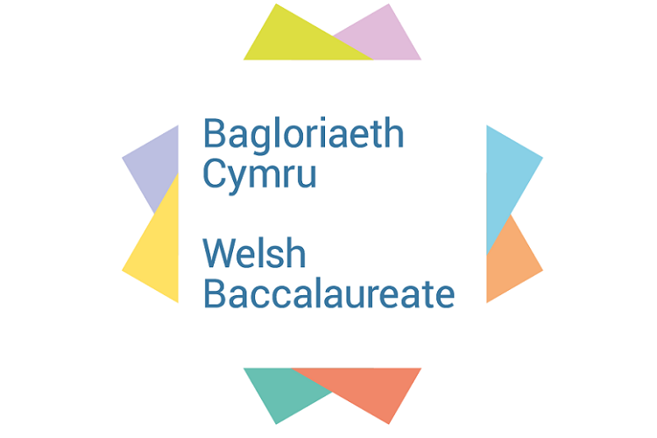
Core Curriculum - Welsh Baccalaureate
Qualification: Welsh Baccalaureate
Examination board: WJEC
Duration: 2 years
Best point of contact: Acook@easternhigh.org.uk

What are the main topics I will study for this qualification?
The Skills Challenge Certificate consists of 3 components:
- Individual Project (50%)
Plus 2 of the below challenges at 25% each
- Enterprise and Employability Challenge
- Global Citizen Challenge
- Community Challenge
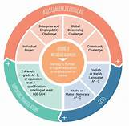
How will I be assessed in this subject?
The National Welsh Bacc is awarded at a Pass grade when learners achieve all elements of the wheel at an A* to C grade.
The Foundation Welsh Bacc. is awarded at a Pass grade when learners achieve a Pass* or Pass in the Skills Challenge Certificate, and an A* to G in the other qualifications on the wheel.The ‘Welsh Bacc. Wheel’ demonstrates all in one place the academic ability and skills competency of a learner.
Important information
The National/Foundation Welsh Baccalaureate provides a vehicle for learners to consolidate and develop integral and cross curricular skills. The qualification helps learners to prepare for their future by developing skills, attributes and behaviours valued by educators and potential employers. The emphasis in the Welsh Baccalaureate is on applied learning i.e. acquiring and applying a range of transferable skills. Learners will develop skills in the context of purposeful tasks and appropriate knowledge and understanding. The National/Foundation Welsh Baccalaureate encourages the learner to value skills development as a key aspect of education and life-long learning. It fully embraces and consolidates the core purposes of the Curriculum for Wales, supporting learners to become:
• ambitious, capable learners, ready to learn throughout their lives
• enterprising, creative contributors, ready to play a full part in life and work
• ethical, informed citizens of Wales and the world
• healthy, confident individuals, ready to lead fulfilling lives as valued members of society.
What can I do at home to support my studies?
Keep abreast of recent issues within your local community and globally - discuss these with your parents and how you would make a difference if you were in the position to.


Core Curriculum
Equality & Diversity
Best point of contact: rnicholas@easternhigh.org.uk

What are the main topics I will study for this qualification?
Students will cover a number of topics including the following:
Equality and Diversity in Society
Equality and Diversity in the Community
Equality and Diversity in the Workplace
How will I be assessed in this subject?
There is no formal examination and students are assessed by the work they complete in class. This qualification is equivalent to either one or two GCSE’s.


Health and Wellbeing
Best point of contact: lkeyworth@easternhigh.org.uk

What are the main topics I will study for this qualification?
Students will cover a number of topics including the following:
-staying safe online
-healthy relationships
-Careers
-Healthy eating and looking after our bodies
How will I be assessed in this subject?
There is no formal assessment for this subject and students will not sit any examination.


Option Subjects
Art & Design – Fine Art
Qualification: GCSE Art & Design
Examination board: WJEC
Duration: 2 years
Best point of contact: lmurray@easternhigh.org.uk
What are the main topics I will study for this qualification?
The coursework is worth 60% of the final grade and the main topic for this will be ‘IDENTITY’. You will start with a ‘self image’ and then continue to choose an aspect of your identity which could be to do with your culture, family, background, hobbies or just a theme that you are influenced by such as nature, sport, film or music. Within this theme you will use a wide range of techniques and a variety of materials as well as taking photographs, looking at various artists, craft workers, art movements and cultural influences.
You will have the opportunity to work within printmaking and use three-dimensional materials such as clay and mod roc to create fine art sculptures and vessels. You will use other materials available to the department, as well as developing the most fundamental skills of drawing and painting.
You will prepare for and sit a 5 hour Year 10 mock exam where you will have the option to choose a theme of your choice and work through a variety of materials and ideas leading to a final creative 2D or 3D piece. This will lead to your final 10 hour exam which accounts for 40% of your final grade.
How will I be assessed in this subject?
COURSEWORK: 60%
EXTERNALLY SET TASK: 40%
Your work will be assessed by referring to the assessment objectives:
AO1 Contextual Understanding
AO2 Creative Making
AO3 Reflective Recording
AO4 Personal Presentation
Am I suited to Art GCSE?
If you have some creative ability, enjoy art and you are creatively committed to trying your best then Art is a great option for you to take.
Generally, if you have achieved a C grade or above at the end of Year 9 you will make a successful GCSE student who could achieve a grade C or above at GCSE as we always notice creativity at an early stage of your experimental journey.
Hard work, independent learning, attendance to art clubs, homework and full commitment is required for this course.
What do current students say about this course?
‘Art GCSE is one of the most interesting subjects you could possibly take! There’s a lot of creativity and interesting things you could get into and learn about’
‘GCSE art is fun and it can help me in life to do what I want to do. I want to be a tattoo artist when I leave school’
‘I enjoy GCSE art because art speaks where words are unable to explain’
‘Art enables us to find ourselves and lose ourselves at the same time’
‘I enjoy GCSE art because I can express myself and do the things I love. Art is AMAZING’


Art - Textiles and Fashion
Qualification: GCSE Art & Design (Textiles)
Examination board: WJEC
Duration: 2 years
Best point of contact: lmurray@easternhigh.org.uk

What are the main topics I will study for this qualification?
Your coursework is worth 60% of your final grade and you will work on this from the start of the course in Year 9 until January when you are in Year 11.
You will be set one big project, which will revolve around the theme ‘The Natural World’ which could be to do with plants, trees, flowers, animals, insects, fish, butterflies etc. When working within this theme you will use a wide variety of textile techniques and materials. You will be looking at various Textile Artists, Fashion Designers, Craft Workers, Art Movements and Cultural Influences.
You will have the opportunity to work with a range of exciting textile techniques including machine embroidery, printing, dyeing, beading, heating, soldering, melting, pleating etc. You will create a range of experimental work, fashion accessories such as bags, hats and shoes, fabric jewellery, 3D structures and fashion garments. You will also be expected to research, record ideas and designs in a sketchbook that you will develop throughout the course.

Your exam is worth 40% of your final grade and you will work on exam preparation from January until March in Year 11. This will lead to your final 10 hour final practical exam which will be based on a question of your choice.

How will I be assessed in this subject?
COURSEWORK: 60%
EXTERNALLY SET TASK: 40%

Your work will be assessed by referring to the assessment objectives:
AO1 Contextual Understanding
AO2 Creative Making
AO3 Reflective Recording
AO4 Personal Presentation
Am I suited to Textiles GCSE?
If you have some creative ability, have an interest in Fashion and Textiles, enjoy designing and making and you are creatively committed to trying your best then Art Textiles is a great option for you to take.
Hard work, independent learning, attendance to Textile clubs and Clothes Show trips, homework and full commitment is required for this challenging and very successful course.
What do current students say about this course?
‘The textiles lessons are a great experience, we get to learn new skills and I really look forward to practical lessons every week.’ Holly Rudyj
‘I like textiles because you get to make fantastic pieces of work; it’s really fun and a good practical subject to enjoy.’ Olivia Sullock
‘There is a lot of work but seeing the final product is amazing.’ Melissa Jenkins


Computer Science
Qualification: GCSE Computer Science
Examination board: WJEC
Duration: 2 years
Best point of contact: mroberts@easternhigh.org.uk

What are the main topics I will study for this qualification?
In Computer Science, students explore fundamental principles such as abstraction, decomposition, logic, algorithms, and data representation. The curriculum emphasises problem-solving through practical programming experience, fostering creative, innovative, analytical, logical, and critical thinking. Students gain a comprehensive understanding of digital systems, their components, communication mechanisms, and societal impacts.

Mathematical skills relevant to computer science are also applied. The course integrates programming, system development (using Python Programming and Greenfoot), computer architecture, data, communication, and applications, promoting a broad skill set.
How will I be assessed in this subject?
The course is split into three key assessment components. A piece of coursework will require students to create a computer programme using a variety of software and will account for 30% of the qualification. The remaining 70% will be assessed through the GCSE exams in June of Year 11. Work towards the examination begins from the moment students enter year 10.

Unit 1: Understanding Computer Science Written examination: 1 hour 45 minutes 50% of the qualification
- This unit investigates hardware, logical operations, communication, data representation and data types, operating systems, principles of programming, software engineering, program construction, security and data management and the impacts of digital technology on wider society

Unit 2: Computational Thinking and Programming On-screen examination: 2 hours 30% of the qualification
- This unit investigates problem solving, algorithms and programming constructs, programming languages, data structures and data types and security and authentication.

Unit 3: Software Development Non-exam assessment: 20 hours 20% of the qualification
- This unit requires learners to produce a programmed solution to a problem. They must analyse the problem, design a solution to the problem, develop a final programmed solution, test the solution and give suggestions for further development of the solution. Throughout the production of the solution learners are required to produce a refinement log that evidences the development of the solution.
Am I suited to Computer Science?
This course is suitable for individuals with an interest in technology, logic, and problem-solving. It is designed to cater to students who wish to understand and apply the principles and concepts of computer science. If you enjoy thinking creatively, innovatively, analytically, logically, and critically, and have an interest in the impacts of digital technology on individuals and society, then you are likely well-suited to pursuing Computer Science at the GCSE level. Resilience, self-sufficiency and a drive to explore are prerequisites for the course, and a strong subject foundation of Mathematics is desirable!
What do current students say about this course?
The hands-on nature of the assessments allows students to showcase their problem-solving abilities, providing valuable practical experience. Overall, feedback from current students emphasises the course's alignment with the demands of modern technology and its engaging, skill-enriching content.


Digital Technology
Qualification: GCSE Digital Technology
Examination board: WJEC
Duration: 2 years
Best point of contact: mroberts@easternhigh.org.uk

What are the main topics I will study for this qualification?
Digital Technology offers a comprehensive exploration of digital skills, knowledge, and understanding applicable in both academic and everyday contexts. Students delve into the diverse landscape of digital technology systems, understanding their value, perspectives, and impact on organisations and individuals. The curriculum covers data, digital communications, securing data and systems, and evolving digital technologies.

Elements of the subject itself can be closely compared to marketing, advertising and digital communications. The course is not ‘ICT’ and requires a genuine interest in Game Development and technical subject knowledge.

Game creation, video creation and how to meet the needs of a target audience are subjects covered within the topic that goes to make this a great choice for students to express their creativity, logic and resilience.
How will I be assessed in this subject?
The course is split in to three key topic areas. The subject is heavily weighted to coursework, with 30% dedicated to game creation and data cleansing, 30% dedicated to online marketing and the remaining 40% as an end of topic theoretical examination.

Unit 1 - “The Digital World” (Exam)
- on-screen examination focusing on digital technology systems
- Focussing on the value of digital technology, ethical perspectives and hardware/software components.
Unit 2 - “Digital Practices” (Coursework NEA)
- Non-exam assessment requiring learners to interrogate spreadsheet data and create a data-informed digital product
- Students will create a game from the ground up using industry leading software ‘Gamemaker’
Unit 3 - “Communicating in the Digital World” (Coursework NEA)
- Non-exam assessment requiring learners to create a digital marketing campaign following a specific scenario
- An understanding of the value in social media, online marketing communications, creating a digital asset using industry leading software Adobe Premier Pro.
Am I suited to Digital Technology?
Digital Technology suits individuals seeking to develop into independent, confident, and knowledgeable users of various digital technologies. It is designed for those interested in understanding the impact of digital technologies on individuals and society, exploring different digital technology systems across occupational sectors, and developing skills in data organisation, analysis, and digital product creation. The course fosters creativity, problem-solving, and a comprehensive understanding of the systems development life cycle. Particularly, students wishing for a career involved in planning, advertising or marketing will benefit greatly from the course!
What do current students say about this course?
Students enjoy the opportunity to create digital products for authentic needs, developing transferable skills in hardware and software use. The course is seen as a pathway to careers involving digital technologies or further advanced learning in the field.

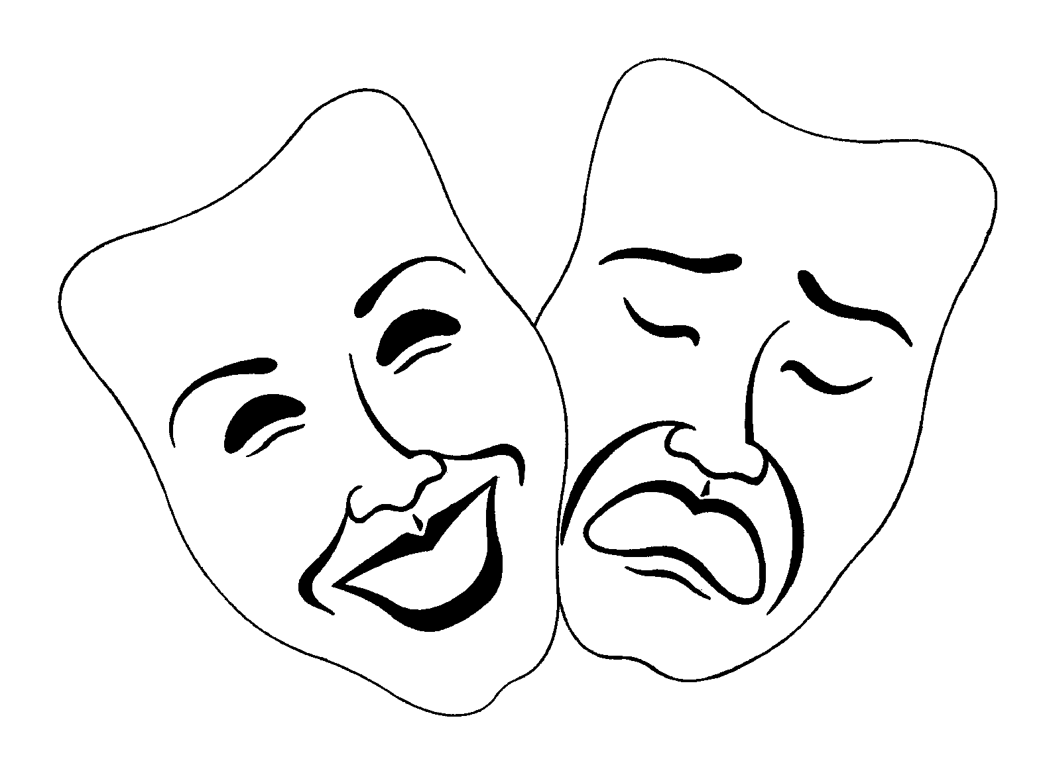
Drama
Qualification: GCSE Drama
Examination board: WJEC
Duration: 2 years
Best point of contact: ledwards@easternhigh.org.uk

What are the main topics I will study for this qualification?
There are 3 main units of study: Unit 1: Devising Theatre, Unit 2: Performing Theatre, and Unit 3: Interpreting Theatre.

Unit 1: Devising Theatre. Pupils create their own piece of theatre in the style of a theatre practitioner/genre in response to a given stimulus e.g. a quote, song, picture. This can be completed as a performer or a designer.

Unit 2: Performing Theatre. Pupils will perform an extract from two different theatrical texts. This can be completed as a performer or a designer.

Unit 3: Interpreting Theatre. Pupils will complete a written exam. The exam is split into section A and Section B. Section A is based on a set text that pupils will explore in lessons from the perspective of an actor, designer, and director. Section B is a Live Theatre Review based on a live performance they have seen over their course of study.
How will I be assessed in this subject?
Unit 1: Devising Theatre is 40% of the qualification. Pupils will be assessed internally. They are assessed on their rehearsal logs, performance, and evaluation.

Unit 2: Performing Theatre is 20% of the qualification. Pupils’ performances/designs will be assessed by a visiting external examiner.

Unit 3: Interpreting Theatre is 40% of the qualification. Pupils will be assessed in a written exam based on their responses to a series of questions based on their set text and a live performance they have watched.
Am I suited to Drama?
As a subject, Drama provides some of the most transferable skills that you will use in your adult life:
• Drama teaches you to work as part of a team. In Drama you will learn to balance ideas, work with and
listen to others, evaluate your work and develop your organisational skills.
• Drama gives you the confidence to perform and present in front of others. When you go for job,
college or university interviews, or lead a presentation at work, studying Drama will provide you
with the required skills to communicate and deliver confidently in front of others.

Drama GCSE is absolutely for you if:
• You have an interest in performing
• You want to develop your confidence
• You enjoy working as part of a team
• You have an interest in watching performances
• You are interested in other roles within theatre, such as directing or designing
• You like working practically
• You are committed and enthusiastic about Drama

If you wish to continue studying Drama at a higher level, then studying GCSE Drama will prepare you for higher education such as A Level Drama. If you wish to pursue Drama as a career option then there are a number of routes that you can take such as acting, directing, teaching, stage management, costume design, set construction, lighting and sound technical work.


Product Design (Design and Technology)
Qualification: GCSE
Examination board: WJEC
Duration: 2 years
Point of contact: cjohnson@easternhigh.org.uk
Design and Technology is a broad subject that appeals to pupils that are looking to pursue a career in the creative industry or skilled professions such as; Architect, Graphic Designer, Engineer, Carpenter, Plumber or Electrician.
What are the main topics I will study for this qualification?
Design Process: Understanding the stages of design, from initial idea generation to final product evaluation.
Materials and Properties: Learning about different materials and their properties.
Manufacturing Processes: Exploring various manufacturing methods such as injection molding, casting, machining, and 3D printing.
Health and Safety: Understanding health and safety considerations when designing and manufacturing products.
Computer-Aided Design: Introduction to CAD software for creating product designs.
Prototyping: Creating prototypes using different materials and techniques to test and refine designs.
Ergonomics and Anthropometrics: Considering human factors in design, such as sizes and human comfort.
Sustainability: Exploring sustainable design practices and considering environmental impacts throughout the design process.
Commercial Manufacturing: Understanding how products are manufactured on a larger scale.
Product Analysis: Analysing existing products to understand design features, functionality, and user experience.
Design Influences and Trends: Studying historical and contemporary design movements.
Evaluation and Iteration: Evaluating finished products against design specifications and user feedback.
How will I be assessed in this subject?
In the first year of your study, you will gain the knowledge and understanding of the different techniques, materials, processes and regulations that professionals have to work with to solve real life problems. You will be assessed on your ability to recall, apply and evaluate your knowledge and skills in product design throughout each topic.
You will be expected to maintain and show good progress and attendance in Year 10 to be entered for the GCSE in Year 11.

In Year 11 there are 2 assessments consisting of:
A design and make task: (approximately 35 hours coursework) where you will have to investigate, design, make and evaluate a product based on a problem set by the WJEC.
A written examination: (2 hours) A mix of short answer, structured and extended writing questions assessing your knowledge and understanding of product design.
Am I suited to DT?
Engineer
Designer
Printer
Interior Design
Branding
Mechanic
Product Designer
Inventor
Kitchen Designer
Interior Designer
Architect
Gas Engineer
Builder
Town and country planner
Plasterer
Surveyor
Gardener
Site Manager
Health and Safety Officer
Project Manager
CAD Technician
Plumber
Carpenter
Electrician
Welder
Manufacturing
Tiler
Scaffolder
Bricklayer
Roofer

This course is suited to individuals that like:
- Making things out of different materials.
- Drawing and sketching.
- Model making
- Work with accuracy and precision.
- Drawing and designing on computers.
This course is an ideal platform for those that wish to:
- Work in a design, media and skills industry.
- Further their studies in college through A-levels.
What do current students say about this course?
“I enjoy the making side of Design and Technology and using the different equipment to make something that I designed. I find the drawing a bit difficult but we use lots of ways to communicate my ideas like using a computer to draw. Some of the theory can be a bit hard, but it is important as you can make the right decisions on how to do something.”


Hospitality and Catering (Food Technology)
Qualification: GCSE
Examination board: WJEC
Duration: 2 years
Best point of contact: cjohnson@easternhigh.org.uk

What are the main topics I will study for this qualification?
The ability to plan, prepare and present food is an essential skill within the hospitality and catering industry. The course equips you with theoretical knowledge about the industry as well as enabling you to develop practical skills in planning, preparing and cooking a variety of dishes. Whether you are interested in becoming a Caterer, Chef, Nutritionist, Dietician or working for companies such as Tesco, Asda, Nestle, or even Food Journalism, this course will provide you with all the fundamental skills needed to enter this massive industry. Everyone needs to eat, there will always be a job in food!
What are the main topics I will study for this qualification?
- Food safety and hygiene regulations
- Nutrition and dietary requirements
- Culinary techniques and skills (e.g., chopping, baking, grilling)
- Menu planning and design
- Food presentation and garnishing
- Kitchen equipment and its uses
- Understanding different cooking methods
- Food preparation and cooking processes
- Hospitality industry sectors and career opportunities
- Customer service skills and techniques
- Health and safety in the kitchen and hospitality environments
- Sustainability and ethical considerations in food production and service
- Marketing and promotion in the hospitality industry
- Cultural influences on food and dining experiences
How will I be assessed in this subject?
Throughout the course you will be assessed on your learning progress and provided with feedback and support to help you reach or exceed your target grades. In year 11 you will predominantly be focussed on completing the following to achieve your GCSE grade.
Unit 1: The Hospitality and Catering Industry will be externally assessed (90 Marks)
You will focus on learning about different types of providers, legislation, food safety and the roles and responsibilities within the sector.
- Written assessment is 90 mins in length
- 40% of qualification
Unit 2: Hospitality and Catering in Action is internally assessed
You will develop practical skills for planning, preparing, cooking and presenting nutritional dishes to meet specific client’s needs. This assessment will allow you to showcase the food preparation skills you have developed through your practical lessons.
- 60% of qualification
- 9 hours allocated for this assessment
Am I suited for this course
Career paths
Catering assistants
Chefs,
Catering/Functions
Food technologists Food safety office, Dietician
Home Economist
Health care industry

This course is suited to individuals who :
- are creative
- enjoy planning, preparing and cooking variety of foods
- have an interest in the functional and chemical characteristics of food
- enjoy learning about the relationship between diet, nutrition and good health
- would like to explore ingredients and processes from different culinary traditions


French
Qualification: GCSE
Examination board: WJEC
Duration: 2 years
Best point of contact: jmontefusco@easternhigh.org.uk

What are the main topics I will study for this qualification?
The emphasis is on COMMUNICATION. During the two-year course 4 areas are explored:-
Personal and Social Life – self, family, friends, home, shopping, meals, healthy living, illness, free time, fashion, relationships. Local Community – home town, school, education, environment, pollution, local facilities, weather and seasons.
The World of Work – work experience, part-time jobs, future careers, technology (e.g. sending emails).
The Wider World – travel and holidays, media, social issues (e.g. life of young people today, drugs, healthy living), life in countries where French is spoken.
How will I be assessed?: This draft summary provides an outline for the specification and sample assessment materials that are being developed for review by the regulator in Wales.

Skill | Exam Papers |  | Weighting
Skill | Foundation  Grades C - G | Higher  Grades A* - D | Weighting
Listening and responding | 35 minutes | 40 minutes | 25%
  Listening tasks with non-verbal and written responses
Reading and responding  Reading tasks with non-verbal and written responses, including one translation task from French into English | 60 minutes | 75 minutes | 25%
Writing  Writing tasks including one translation task from English into French | 75 minutes | 90 minutes | 25%
Speaking | 1 task done over 2 years |  | 25%
  One role play, One photo card discussion
  One conversation

Am I suited for this course?
This course is suited to individuals who :
- have a genuine curiosity and interest in learning languages
- are open minded and culturally aware
- have good communication skills
- enjoy a challenge
- are Interested in learning languages
- are committed to consistent studying
- are open-minded and culturally aware
- have good communication skills

Careers linked to French GCSE:
Wine Sommelier, Fashion Stylist, Culinary Artist/Chef, Film Critic/Reviewer, Event Planner, Adventure Tour Leader, Travel Blogger/Influencer, Voice Actor, Artisan/Craftsperson, Musician, Entertainer
- What do current students say about this course?
- "I love the challenge of learning a new language, and French has been incredibly rewarding."
- "GCSE French has helped me develop valuable communication skills that I can use in everyday life."
- "Learning French has sparked my curiosity about other languages and cultures around the world."
- "I appreciate how studying French has broadened my perspective and understanding of different cultures."


Geography
Qualification: GCSE Geography
Examination board: WJEC
Duration: 2 years
Best point of contact: Emeyrick@easternhigh.org.uk

There’s more to geography than being concerned about climate change and locating places on a map! To prove it, here are some of the ways in which geography impacts on your daily life:
- Snapchat, Facebook and Instagram all use location services and maps
- Computer Games such as Fortnite, Minecraft and GTA (to name just a few) use maps, planning tools and iconic landmarks, all of which wouldn't be possible without the help of a geographer!
- Mcdonalds, Dominos, Coke, Nike - major brands like these as well as food from different cultures wouldn’t be available to you if it wasn’t for globalisation, a key topic when studying geography. Imagine how awful your life would be without your favourite meal, mobile phone or best trainers :(
- The weather - predicted by meteorologists so that you can prepare for a day at the beach or a day binge-watching Netflix. Geography helps you understand how to forecast the weather.
Learn skills and content that link to your life! The modules taught in GCSE Geography are interesting and are relevant to your life, they cover newsworthy topics that affect YOU and YOUR life.
What are the main topics I will study for this qualification?
- Landscapes and Physical Process (Rivers and Coasts)
- Rural Urban Links
- Tectonic Landscapes and Hazards (Volcanoes and Earthquakes)
- Weather and Climate
- Development and Resource Issues
- Social Development Issues or Environmental Challenges - This will be decided as a class
At least two fieldwork opportunities in two contrasting environments
How will I be assessed in this subject?
- Unit 1- Written Paper: 1 hour 30 minutes (40%) Summer Year 11
- Unit 2- Written Paper: 1 hour 30 minutes (40%) Summer Year 11
- Unit 3- Controlled Assessment- Field work (20%) Autumn Year 11
Am I suited to Geography GCSE? The course is broad and allows for insight into some of the key concepts in today’s society. The course develops thinking skills and allows pupils to develop their decision making abilities on topics that are applicable to their lives and futures. Numeracy plays an important role in all of the topics studied at GCSE. Some of the key numeracy skills pupils must be able to demonstrate are; analysing graphs, the use of scale and distance on maps and interpreting information in tables. The skills learnt in geography make geography graduates some of the most employable across the whole of the job market. Jobs can vary from urban planning to engineering, from teaching to disaster mapping and emergency services. The opportunities are limitless.
What do current students say about this course? ‘Geography has allowed me to look at things in a different way, the topics are interesting and there are always things on TV that relate to it, which makes it even more exciting to learn.’ ‘I enjoyed the fieldwork it allowed me to get out of the classroom to collect my data and create my own investigation.’


Health and Social Care, and Childcare
Qualification: GCSE
Examination board: WJEC
Duration: 2 years
Best point of contact: emeyrick@easternhigh.org.uk

What are the main topics I will study for this qualification?

You will have the opportunity to develop your understanding of influences on human growth, development, behaviour and well-being. You will also gain an understanding of the social, physical, emotional, and cultural needs of people who use care and support services, and recognise that each individual has a unique blend of abilities and needs. Active learning and personalisation are promoted by giving you opportunities to investigate care issues and topics of your own choice.
Throughout the two year course you will study:

Unit 1 - Human development across the life cycle, including:

- Physical, social, emotional and intellectual milestones and the impacts on these such as illness, disease and disability, life experiences (to include ACEs) and living conditions.
- The interdependence between physical health and wellbeing and mental health and wellbeing.
- Early intervention and prevention to promote and support growth, development and well-being for a range of conditions and circumstances.

Unit 2 - Promoting and maintaining health and well-being, including:

- The range of health and social care, and childcare provision in Wales aimed to promote and support health and well-being.
- The professionals that work within the Health and social care, and childcare sectors.
- The range of materials and campaigns available to try and help support and guide people in making healthy lifestyle choices.

How will I be assessed in this subject?
- Unit 1- Written Paper: 1 hour 30 minutes (40%) Summer Year 10
- Unit 2- Controlled Assessment- Written Portfolio (60%) To be submitted Spring Year 11
What do current students say about this course?
“I’ve found Health and Social Care to be really relevant to me and my life; watching the Jesy Nelson documentary made me think about the impact that social media has on me and my friends, and how the comments made can really affect people.”
“I’ve really enjoyed learning about development across the life stages and linking milestones to what my baby brother is able to do, it makes it easy to link real life and school work”


History
Qualification: GCSE
Examination board: WJEC
Duration: 2 years
Best point of contact: Jcuff@easternhigh.org.uk

What are the main topics I will study for this qualification?

At Key Stage 4, pupils studying History at Eastern High will complete four units.

Unit 1: This unit will consider a Welsh perspective within a British historical context.
Depression, War and Recovery, 1930-1951.
- The Impact of Depression
- Preparations for war against Hitler and the Nazis
- The experiences of World War Two e.g. the bombing of cities, rationing and evacuation
- Post war Wales and Britain.

Unit 2: This unit will consider history in a wider world context.
The USA: A Nation of Contrasts, 1910-1929.

- The Political and Social Challenges e.g. immigration, treatment of black Americans, the rise of the gangsters
- The rise and fall of the economy
- Popular entertainment e.g cinema, jazz and the speakeasy culture.

Unit 3: This unit will be a thematic study, covering an aspect of History.
Changes in Crime and Punishment, c.1500 to the present day.

Pupils will study crime & punishment from Tudor times to the growth of terrorism in the 21st Century.

- Causes of crime
- The nature of crime
- The enforcement of law and order.
Unit 4: Non-examination Assessment, with a focus on the First World War.

How will I be assessed in this subject?
There will be three exams: an exam for units 1-3. Units 1 and 2 account for 25% of the qualification. Unit 3 accounts for 30% of the qualification.
You will also be required to complete two non-examination assessment pieces. These will make up the final 20%.
What do current students say about this course?
“History has helped me understand about things that have happened and why some things are the way they are now. It is a bit of a challenge, but it is a challenge worth taking and I thoroughly enjoy it.” Year 9 pupil.


Media Studies
Qualification: GCSE Media Studies
Examination board: WJEC
Duration: 2 years
Best point of contact: mpaynter@easternhigh.org.uk

What are the main topics I will study for this qualification?
In Media Studies, you will study media concepts such as audience, narrative, representation, genre and marketing. You will analyse and create a variety of exciting and contemporary media texts including: adverts, films, film trailers, film posters, radio programmes, newspapers, video games, music videos and websites. You will spend time in the classroom and the computer room; this will raise your awareness of the convergent nature of media, and improve your technical skills.
How will I be assessed in this subject?
Coursework, which consists of creating a media product, makes up 40% of your overall grade.
There are two written examinations, which make up the other 60%. The first examination requires you to explore Media Language and Representation, whereas the second examination requires you to show understanding of Media Forms and Products.
Am I suited to Media Studies GCSE?
If you have an interest in modern media communication, you will enjoy this subject.
You will learn about media concepts such as representation, audience, genre and media industries.
You will study the following media forms:
- film
- newspapers
- radio
- television
- advertising
- video games
- magazines
- music videos
- online and social media
Current media classes have also had the opportunity to visit the ITV studios and look at what goes on behind the scenes, as well as using technical equipment such as cameras. They also had the opportunity to present the news and weather.
Careers linked to media studies:
- Digital Marketer
- Media Planner
- Music Producer
- Runner, broadcasting/film/video
- Social Media Manager
- Television/Film/Video Producer
What do current students say about this course?
‘I enjoy Media Studies because it is a fun educational experience. We have been learning about advertising campaigns, ranging from posters and television adverts.’


Music
Qualification: BTEC Level 1/2 First Award
Examination board: Edexcel
Duration: 2 years
Best point of contact: epawsey@easternhigh.org.uk

What are the main topics I will study for this qualification?
There are 2 compulsory units - The Music Industry, which leads to an exam and Managing a Music Product, in which you will work in groups to design, record and promote your own CD.
You will also need to complete 2 optional units to make up the qualification. These will be chosen from Music Performance, Music Composition, Music Sequencing and The Development of Music.
Music Performance will focus on producing videos of you performing your choice of music, and developing your skills to improve in this area, including keeping a regular practice diary.
Music Composition will involve creating and developing your own musical ideas, maybe writing a song or a piece of music for film.
Music Sequencing will be about using computers to produce music, using the new IT equipment.
The Development of Music will take a look at how music has changed through time.
There may be an opportunity for some Students to complete a separate Music Technology course as well, which will lead to a further GCSE equivalent qualification.
How will I be assessed in this subject?
Most of the course will be made up of assignments, which will be assessed by your teacher, and moderated by an external person. Some of these will be written, some will be practical. Most will be individual work but there will be some group work too. You will have strict deadlines to work to and will get feedback on how to improve your work.
There will be one examination on the Music Industry, which you will take during Year 11.
Am I suited to BTEC Music?
Yes, if you have an interest in the way the Music Industry works – how a song gets from being just an idea in somebody’s head to a recording played on the radio and downloaded from iTunes.
You also need to be interested in performing, including in front of other people, and making up your own music.
You don’t need to play an instrument but if you don’t, then you must be willing to sing.
There is a lot of independent work in this course, so you must be able to focus and concentrate on what needs to be done, especially if those around you are working on something else.
You will have homework and will also be expected to practice regularly for performances.
Don’t forget that for a BTEC qualification there is written work (as in a GCSE) so do not assume that you will just spend 2 years playing on a keyboard. We are here to help you to achieve your best and will have high expectations.
This course will allow you to demonstrate a huge number of skills, which will be useful for you in the future. These include confidence, creativity, both team and individual work, perseverance and determination.


Performing Arts
Qualification BTEC Performing Arts
Examination board: Edexcel
Duration: 2 years
Best point of contact: Epawsey@easternhigh.org.uk

What are the main topics I will study for this qualification?
You will study the following units:-
Individual Showcase
Preparation, performance and production
Musical Theatre
How will I be assessed in this subject?
There is a mixture of internally and externally marked work. All performance work is accompanied with written logs that reflect and analyse pupils' work.
Am I suited to BTEC Performing Arts?
The course requires hard work, dedication, excellent team work and enthusiasm. You must have a love for performing and must want to improve the three main areas of Dance, Drama and Music. You must be prepared to perform in front of others and work as a team.
What do current and past students say about this course?
“The course has improved my confidence not just in actually getting up and performing but going to College and getting interviewed for a place on a course I really want to do next year. I never would have been able to do it if I hadn’t taken Performing Arts” Chardelle Smith year 11 (past student)

‘ This course has improved all my skills in Musical Theatre, especially my singing and acting. , I feel very comfortable with how I perform . It has also made my confidence as a performer and as a person much better and I’ve taken part in lots of activities and shows I would never have done if I wasn’t taking part in Performing Arts’ Laura Dawkes Year 11 (past pupil and current West End star)

“It has provided me with not only skills in dance, singing and acting, but it has allowed me to grow in confidence which I can apply to other subjects” Mia Willecome (Year 10)

“Before, I was really shy and nervous in front of people. Doing Performing Arts has not only ignited my passion for Drama, but has also allowed me to be a more confident person and to take that out into the wide world and channel it towards whatever I want to do with my future” Megan Pontin (Year 11)


Physical Education
Qualification: GCSE
Examination board: WJEC
Duration: 2 years
Best point of contact: Aevans@easternhigh.org.uk

What are the main topics I will study for this qualification?

By choosing GCSE P.E. you will:

• Develop your knowledge and practical skills in a range of physical activities
• Examine the effects of exercise and how training can improve performance
• Find ways to improve your own performances in a variety of roles
• Identify ways to develop and maintain a healthy and active lifestyle through participation in physical activity
• Appreciate the benefits of promoting ‘Sport for All’.

How will I be assessed in this subject?
Unit 1 – Examination
50%
Unit 1 is externally assessed through a written examination paper of 2 hours. This will contribute a maximum of 50% towards your total marks.

Unit 2 – Controlled Assessment
50%
Three practical performances in the role of either player/participant as well as a written Personal Fitness Programme.
You can achieve 50% of the marks from your three performances with one being your main area.
Am I suited to GCSE Physical Education?

The course builds on the knowledge, understanding and skills established in Key Stage 3 Physical Education.
It will give you exciting opportunities to be involved in a number of different physical activities, promoting an active and healthy lifestyle. As a GCSE PE pupil you will be expected to represent the school in a variety of different activities
You should have an interest in physical education and sport, enjoy being active and appreciate the benefits of keeping fit and healthy. The theory part of the course requires you to have a good understanding of a range of sports and strong levels of English and Science.
What do current students say about this course?
"It's really enjoyable but you need to be prepared to work hard - it's not all fun and games."
Rhys Sheldon Year 10 GCSE PE

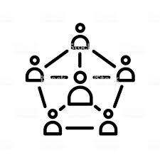
Sociology
Qualification: Sociology 9-1
Examination board: EDUQAS
Duration: 2 years
Best point of contact: mpaynter@easternhigh.org.uk

What are the main topics I will study for this qualification?
Component 1: Understanding Social Processes
This component covers the following topic areas:
Key concepts and processes of cultural transmission, Families, Education, Sociological research methods
Component 2: Understanding Social Structures
This component covers the following topic areas:
Social differentiation and stratification, Crime and deviance, Applied methods of sociological enquiry
How will I be assessed in this subject?
Component 1: Understanding Social Processes
Written examination: 1 hour 45 minutes
50% of qualification
Component 2: Understanding Social Structures
Written examination: 1 hour 45 minutes
50% of qualification
Am I suited to GCSE Sociology?
Do you have an inquiring mind? Have you ever questioned the following:
- How do people learn the rules of their culture?
- How do children learn to act like a boy or a girl?
- Why are people allowed to marry more than one person in other countries?
- What happens to children who are neglected or brought up by wild animals?
- Why do people turn to a life of crime?
- Why are there more single parent families today compared to the 1950s?
- Why are the rich getting richer and some people live in poverty?
- What is the hidden curriculum in schools?
- What is an anti-school subculture?
- Why was homosexuality against the law in the 1960s but today same sex couples can legally marry in the UK?
- How does the media influence the way we think?
- How can racism, sexism, ageism, social class, sexuality and disability have a negative impact on a person’s life-chances?
If you have a keen interest in life around you then sociology is for you.
While finding out about the world around you, sociologists will also develop the ability to show their knowledge and understanding of key concepts and issues in the context of sociological theory. Learners will also select, interpret, evaluate and apply their knowledge and understanding in a range of contexts. These are highly desirable skills required
for college and university.
Careers linked to sociology:
- The Police
- Research
- Social Work and the ‘Caring Professions’
- Teaching Civil Service and Local Government
- Lawyer
What do current students say about this course?
‘I now see life from a different perspective.’ ‘Sociology has made me think about how my life is influenced by society.’


Helpful links and contact information:

Name | Position | Contact details
Alice Ketteringham | Career Advisor | alice.ketteringham@careerswales.gov.wales
Jonathan Morgan | Careers and Aspirations coordinator | jmorgan@easternhigh.org.uk
Hayley McCallion | Assistant Headteacher | hmccallion@easternhigh.org.uk

Careers Wales | Careers Wales (gov.wales) - There is lots of information on here about different pathways including which subjects are best suited to different careers.

